# Assignment briefings (2022/23)

All assignment briefings and marking scheme/rubrics must be published to students via the Assignments section on Canvas, using the Assignments description area.

## What must be included in the Assignments description area.

As before, all assignments must have a name (title). Additionally, the following information must be included in the Assignments ‘box’:

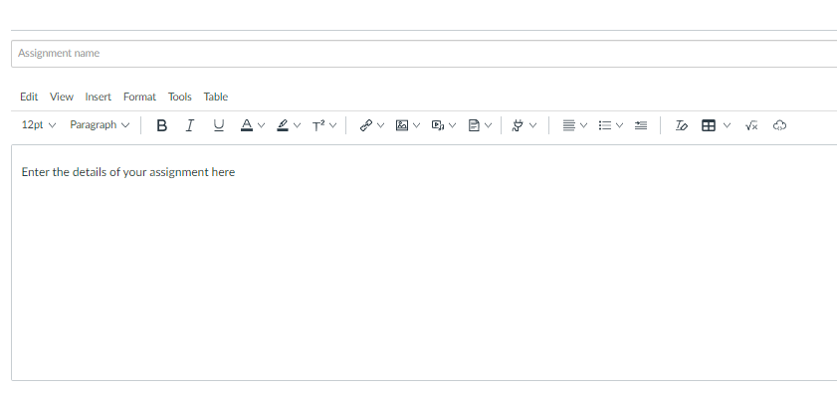

|  |  |  |  |
| --- | --- | --- | --- |
| **Weighting %:** | 30 | **Submission deadline (for students):** | See Canvas |
| **Authorship:** | Individual | **Target date for returning marked coursework:** | 31st April |
| **Tutor setting the work:** | John Evans | **Number of hours you are expected to work on this assignment:** |  |
| **This Assignment assesses the following module Learning Outcomes (from Definitive Module Document):**   1. have knowledge of and understand key data manipulation techniques for data preparation 2. understand how to approach a range of different data science problems to obtain an efficient solution | | | |
| **Assignment Tasks:** See attached pdf | | | |
| **Submission Requirements:** 1 page report + 10 minute presentation (with 5 mins questions) | | | |
| **Marks awarded for:** See attached pdf | | | |
| **Type of Feedback to be given for this assignment:** Written + Verbal | | | |
| **Additional information:**   * Regulations governing assessment offences including Plagiarism and Collusion are available from <https://www.herts.ac.uk/__data/assets/pdf_file/0007/237625/AS14-Apx3-Academic-Misconduct.pdf> (UPR AS14). * Guidance on avoiding plagiarism can be found here: <https://herts.instructure.com/courses/61421> (see the **Referencing** section) * For **undergraduate modules**:   + a score of 40% or above represents a pass performance at honours level.   + late submission of any item of coursework for each day or part thereof (or for hard copy submission only, working day or part thereof) for up to five days after the published deadline, coursework relating to modules at Levels 0, 4, 5, 6 submitted late (including deferred coursework, but with the exception of referred coursework), will have the numeric grade reduced by 10 grade points until or unless the numeric grade reaches or is 40. Where the numeric grade awarded for the assessment is less than 40, no lateness penalty will be applied. | | | |